3.2 Exterior Angles of a Triangle
The exterior angle of a triangle can be found by extending the sides as seen here:
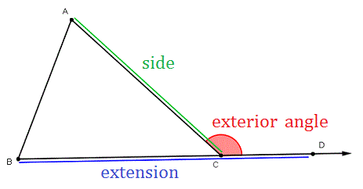
Here are the three rules involving exterior triangles that we need to do today’s lesson:
Rule 1:
The interior angle and exterior angle will add up to 180 degrees
Example:

Rule 2:
Each exterior angle of a triangle is equal to the sum of the two opposite interior angles.
Example:

Rule 3:
The sum of all 3 exterior angles of a triangle is 360⁰.
Example:

